Introduction to Open Source

Version : 1.0

Document Owner : Richard Raju

Document Control Information

 | Role | Name | Date
Document Prepared by |  | Richard Raju | 30-Sept-2011

Reviewed by

Approved by

Revision History:

Version  Number | Revision  Date | Description of Changes
1.0 | 30-sept-11 | Initial version

Course Details

Course Name | Open source and Open Standard
Semester | First
Total Credits | 2
Delivery Duration for this chapter | 1 hour 15 minutes

Table of Content

1 Analogy: Soup and Cola 4

2 Open Source and Closed Source 4

2.1 Open Source 4

2.2 Closed Source 5

2.3 Closed to Open 6

3 Summary 6

4 Disclaimer 7

Analogy: Soup and Cola

Steward! What’s on the menu? Let me start with a soup please.

After a while a hot soup is served on the table. But it may not be exactly what you want, but it fits your needs. The restaurant charges you for the service. That includes price of the soup and serving charges. What is that you did not get to see? - The recipe and the chef. This analogy will help us to understand what is “closed source”? We use the end product without getting to know what goes into it or how it’s done. Probably, you may have a manual with set of instructions to use the product.

Let’s say an innovative restaurant comes up with an idea called “Free Soup”, where a customer can cook a soup in the restaurant on his own with the recipe provided by the restaurant. You cook and you eat, but still the restaurant charges you, may not be for the soup but it may charge you for the service. Moral – Nothing is Free. In this case you had access to their recipe perhaps you wanted to tweak the recipe to suit your taste and also share the modified recipe to the restaurant. As more customers use this service, the user will not only pay less but also help in improving the taste of the soup. This is “open source”.

Let us look at another analogy of Coca-Cola. When consumers buy a bottle of soda and all they get to see is the list of ingredients on the bottle cover but the proprietary formula of Coca-Cola is not on the bottle or anywhere else for us to access. Therefore, no one can reproduce it. In the previous soup analogy certain amount of reverse-engineering probably will bring us to the recipe but surely not with Coca-Cola.

Be it a soup, Cola or a software application, if the access is given to all for the recipe or code in case of software, broadly it can be termed as Open Source.

Open Source and Closed Source

The above analogy gives us a broad idea about Open and Closed source. In this subsection we will define Open Source and closed Source. As we further in this topic we will learn more about the benefits of open source and also the challenges. We will also learn how communities are build and how they help anything from fixing bugs to adding more features to the available “Source code”(Source code – it is a human readable instruction that make up the recipe for the software).

Open Source

Definition: Open Source can be defined as the software which has freedom to use, view, modify and Share.

Use: It is the freedom for anyone to use the program however they wish. Anyone can download and use them for any purpose, be it business, home or education.

View: It is the freedom to study the source code and change as they wish. Anyone can download the source code and view.

Modify: Freedom to distribute copies of modified programs to others when they wish. Anyone can modify the source code for the betterment of the software and give back to community.

Share: It is the freedom to distribute copies of the program to anyone they wish to share. There is no license restriction on number of computer it can be installed on or number of users.

The key point to be noted in the definition is “Freedom”. As stated above, open source gives us the freedom to use, view, share and modify. That does not mean there is no price tagged to it. It is free as in freedom, not to price.

Gratis versus Libre:

“Free software means free speech”. Free is very loosely used word in English. To have a profound understanding we need to look into the distinction between “Gratis” and “Libre” (closely related to liberty). Gratis means, “for zero price” and libre means, “with little or no restrictions”. The latter is applicable when said “free software”.

"Free software is a matter of liberty, not price. To understand the concept, you should think of free as in free speech, not as in free beer." — Richard Stallman

Open source strongly encourages copying and modification. But, any improvement should be given back to community without any restriction. In case of “free soup” analogy, you get to drink the soup, view the recipe, share the soup with your friend maybe and change the recipe to suit your taste.

Example: Mozilla Firefox

Firefox is second most popular web browser developed based on open source principles and available for free. What started as an experimental project by Dave Hyatt and Blake Ross has grown beyond our imagination. This was possible because the firefox browser was available for everyone to download and use. The source code is available for download and can be modified. There is not restriction for sharing firefox.

https://developer.mozilla.org/en/Download_Mozilla_Source_Code

We can be involved in the firefox community in many areas of interest. Visit the following link to choose your area of interest for you to contribute. Remember the more you and I contribute the better the product gets.

http://www.mozilla.org/contribute/

The fact that the source code is available for anyone to review does not make the software free of bugs. If any user with the required knowledge scrutinizes the source code and feeds corrections back to the community, it will help.

Freely available source code is absolutely necessary for fostering innovation. When source code is freely available it brings numerous challenges. How communities will address these challenges? How to stop business to co-opt the code for their own profitability? In the latter chapters we will learn how these challenges are mitigated. We will also learn how companies generate revenue when they give away software or free.

Closed Source

Definition: Closed Source can be defined as the software which are licensed product and has to be bought to use, source code are not viewable by anyone and cannot be modified.

The incentives of closed source are straight forward. A vendor creates a product to be sold. But the buyers are not allowed to modify or redistribute. But, allowed to use with certain terms and conditions. Software is licensed, not sold.

Use: Use of software is totally governed by the license agreement. There are multiple check points to ensure user is limited for the bought license like product key, number of users accessing the software .etc. They have separate licensing scheme for business, home or education. License also restricts the use of functionality of the software.

View: Closed source software is compiled, meaning the actually human-readable version is not visible. When a user buys closed source software they only buy the license to use them but not actually have the source code. This will prevent users to understand how to software works.

Modify: As there is no access to source code, user will not be able to change the software partially or wholly.

Share: Licenses categorically restricts redistribution of closed source software.

Example: Microsoft Windows

Windows is a proprietary operating system from Microsoft. This comes with different license scheme. The licensee has the right to use the operating system under certain terms and condition laid down my Microsoft. But users are restricted from modifying and redistribution the operating system. Copyright, patents, and other legal structures provide a shield to protect their source code.

Closed to Open

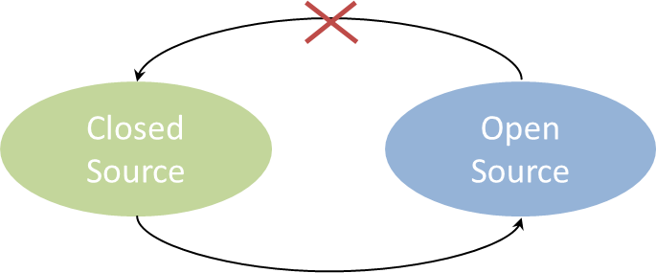
Closed source software can become open when the source code is made available for all by organisation/developer who owns the source code. But, open source should not become closed, which is against the principles of open source. OpenSolaris is an open source operating system based on Solaris by Sun Microsystem.

Summary

To summarize, we discussed the principles of open source. There is no discrimination of where open source can be used. Software is said to be open source when its source code is available to everyone without any kind of restriction. Users get to learn how the software works and can modify as they wish.

On the other hand, closed source software is that you have no idea how it is made. Except, the organization/developer no one will have access to source code and any innovation is limited within the development team.

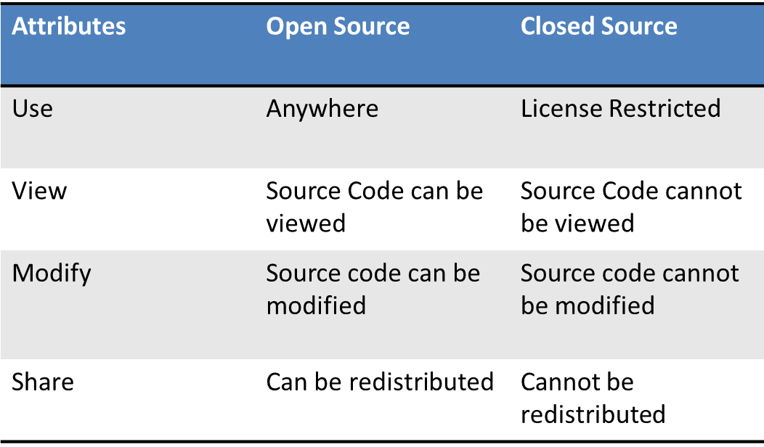

Disclaimer

The contents of this report reflect the views of the author and do not necessarily reflect the official views or policy of the International Business Machines Corporation in the United States and/or other countries. This report does not constitute a standard, specification or regulation.

IBM is a registered trademark of International Business Machines Corporation in the United States and/or other countries.

Other company, product, and service names may be trademarks or service marks of others.

Microsoft is a registered trademark of Microsoft Corporation

